

Undergraduate Lab Report

Course Title: Experiment of Computer Organization
Course No: 60080014
Student Name: 蒋云翔
Student No: 2022102330
School: 暨南大学
Department: 国际学院
Major: CST
Instructor： SUN Heng

Academic Year:2022~2023,Semester : 1st [ √ ] 2nd[ ]

Academic Affairs Office of Jinan University
Date (dd/mm/yyyy)__15/11/2023____
Computer Organization Lab List
Student Name: 蒋云翔 Student No: 2022102330

ID | Lab Name | Type
1 | Number Storage Lab | Individual
2 | Manipulating Bits | Individual
3 | Simulating Y86-64 Program | Individual
4 | Performance Lab | Team
5 | A Simple Real-life Control System | Team
6 | System I/O | Individual
Undergraduate Lab Report of Jinan University
Course Title Experiment of Computer Organization Evaluation
Lab Name Performance Lab Instructor Sun Heng
Lab Address 116
Student Name 蒋云翔 Student No 2022102330
College 国际学院
Department Major CST
Date 15 / 11 / 2023 Morning / Afternoon
- Introduction

The assembly language in Lab 3 is one of the most effective means for gaining an understanding how the code will run in high performance. In this lab, students should optimize the performance of an application kernel function such as convolution or matrix transposition. It provides a clear demonstration of the properties of cache memories and gives them experience with low-level program optimization.

- Lab Instructions or Steps
Image processing problem

Rotate operation
Smooth operation

- Lab Device or Environment
Computer: ASUS天选3 NVIDIA3060 i7
Virtual computer: VMware pro station 17.0 Ubuntu 16.04
- Results and Analysis


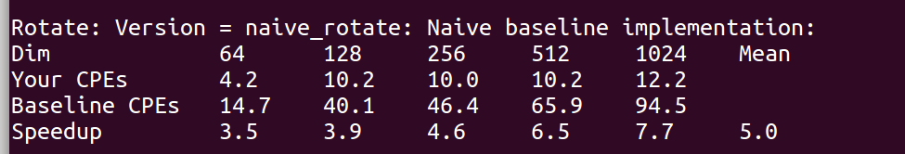

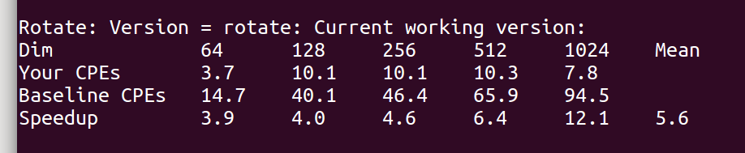

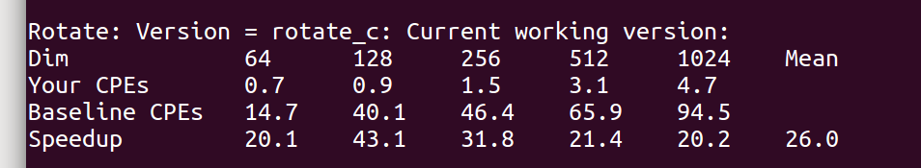
Accessing the pixel data in the main order of the column will lead to the contiguous pixel data is not stored consecutively in the memory, which is easy to cause the cache miss, the need to frequently load data from the main memory or disk storage, and reduce the execution speed of the program. Therefore, by changing the row main order and the column main order, we can optimize the running speed of the program according to the specific image processing algorithm and the memory hierarchy of the computer, and improve the efficiency of image processing.
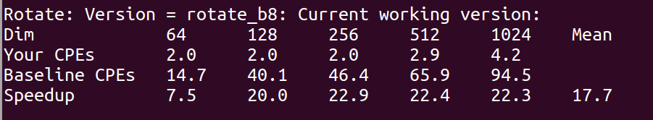
By processing the image into blocks, the number of iterations of each cycle is reduced. This reduces the amount of unnecessary calculation and improves the execution speed of the program. Segmentation of images can also improve parallelism. The pixel processing between different blocks is independent of each other, and multiple blocks can be processed simultaneously by multithreading or parallel computing to further accelerate the processing speed.
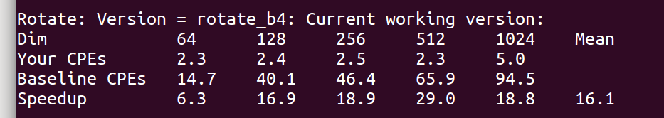
The reason why this 4 × 4 optimization is slower than 8 × 8 May be that it does not take full advantage of the optimization benefits of parallel processing
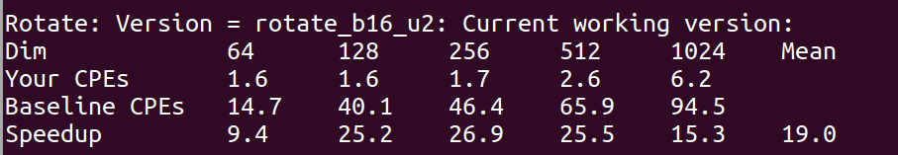
Inside larger blocks, the effect of loop unfolding may be diminished.
Within larger blocks, the opportunity for parallel processing may be reduced. Because larger blocks cause the processing unit to process more data, this can limit the effect of parallel processing, thus slowing down the program.
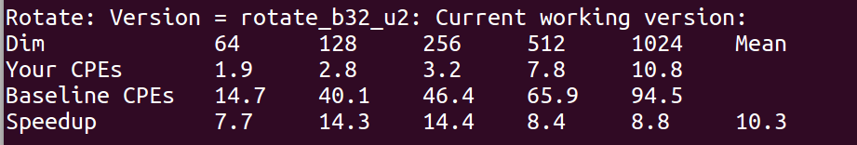
The same reason as above.
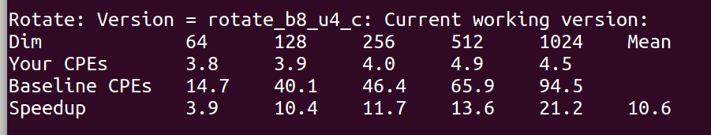
While using the image block processing, the loop expansion is carried out, which does not have fundamental optimization, but increases the use of registers, resulting in slow program running speed
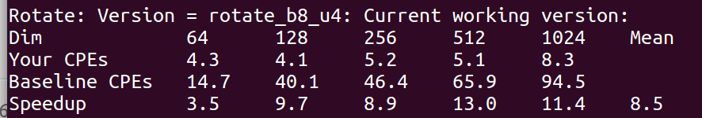
The version has not used the rotate.c method to optimize, so its running speed is slower than the above one.
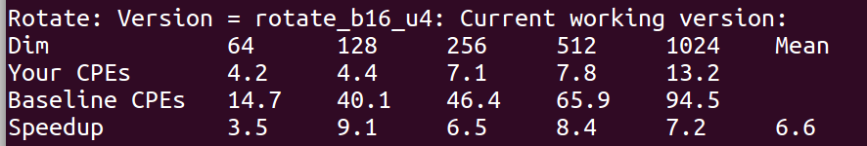
Inside larger blocks, the effect of loop unfolding may be diminished.
Within larger blocks, the opportunity for parallel processing may be reduced. Because larger blocks cause the processing unit to process more data, this can limit the effect of parallel processing, thus slowing down the program.
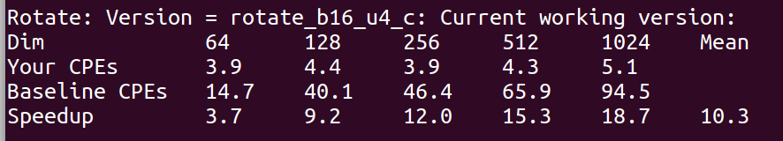
The version uses the rotate.c method to optimize, so its running speed is faster than the above one.

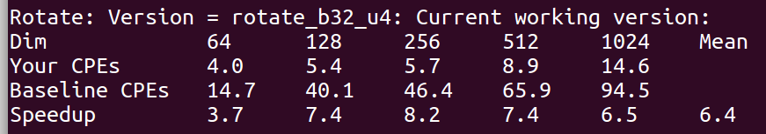
Inside larger blocks, the effect of loop unfolding may be diminished.
Within larger blocks, the opportunity for parallel processing may be reduced. Because larger blocks cause the processing unit to process more data, this can limit the effect of parallel processing, thus slowing down the program.
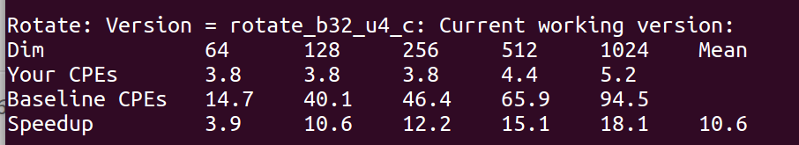
The version uses the rotate.c method to optimize, so its running speed is faster than the above one
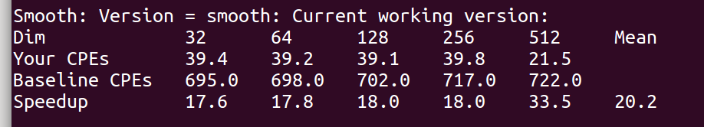

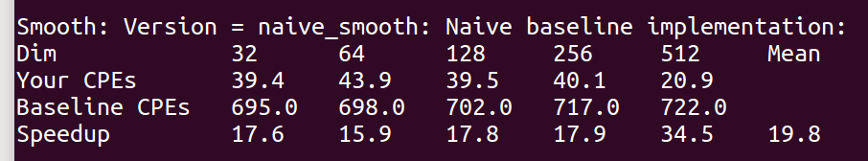

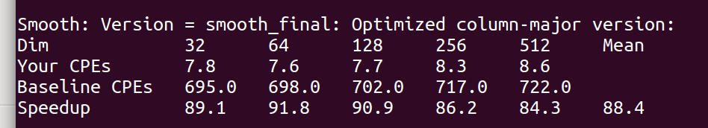
The original smooth function looks very streamlined, but it actually calls a lot of custom functions, just to solve special cases, which slows down the program. Therefore, we can directly write the special case expansion into the smooth_final function, which can improve the running performance by reducing the function tuning.

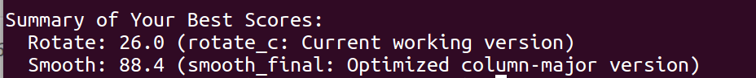
- Appendix (Program Code)
#include <stdio.h>
#include <stdlib.h>
#include "defs.h"

/*
* Please fill in the following team struct
*/

team_t team = {

"CST-LastHero", /* Team name */

"蒋云翔", /* First member full name */

"2864080068@qq.com", /* First member email address */

"", /* Second or third member full name (leave blank if none) */

"" /* Second or third member email addr (leave blank if none) */

};

/***************
* ROTATE KERNEL
***************/

/******************************************************
* Your different versions of the rotate kernel go here
******************************************************/

/*
* naive_rotate - The naive baseline version of rotate
*/

char naive_rotate_descr[] = "naive_rotate: Naive baseline implementation";
void naive_rotate(int dim, pixel* src, pixel* dst) {
int i, j;

for (i = 0; i < dim; i++)

for (j = 0; j < dim; j++)

dst[RIDX(dim - 1 - j, i, dim)] = src[RIDX(i, j, dim)];

return;
}

/*
* rotate - Your current working version of rotate
* IMPORTANT: This is the version you will be graded on
*/

char rotate_descr[] = "rotate: Current working version";
void rotate(int dim, pixel* src, pixel* dst)

{
naive_rotate(dim, src, dst);
}

char rotate_descr_c[] = "rotate_c: Current working version";
void rotate_c(int dim, pixel* src, pixel* dst) {
int i, j;

for (j = 0; j < dim; j++)

for (i = 0; i < dim; i++)

dst[RIDX(dim - 1 - j, i, dim)] = src[RIDX(i, j, dim)];

return;
}

char rotate_descr_b8[] = "rotate_b8: Current working version";
void rotate_b8(int dim, pixel* src, pixel* dst)

{
int i, j, i_1, j_1;

for (i = 0; i < dim; i += 8) {
for (j = 0; j < dim; j += 8) {
for (i_1 = i; i_1 < i + 8; i_1++) {
for (j_1 = j; j_1 < j + 8; j_1++)

dst[RIDX(dim - 1 - j_1, i_1, dim)] = src[RIDX(i_1, j_1, dim)];
}
}
}
}

char rotate_descr_b4[] = "rotate_b4: Current working version";
void rotate_b4(int dim, pixel* src, pixel* dst)

{
int i, j, i_1, j_1;

for (i = 0; i < dim; i += 4) {
for (j = 0; j < dim; j += 4) {
for (i_1 = i; i_1 < i + 4; i_1++) {
for (j_1 = j; j_1 < j + 4; j_1++)

dst[RIDX(dim - 1 - j_1, i_1, dim)] = src[RIDX(i_1, j_1, dim)];
}
}
}
}

char rotate_descr_b16_u2[] = "rotate_b16_u2: Current working version";
void rotate_b16_u2(int n, pixel* src, pixel* dst) {
for (int i = 0; i < n; i += 16) {
for (int j = 0; j < n; j += 16) {
for (int k = 0; k < 16; ++k) {
for (int l = 0; l < 16; l += 2) {
dst[(n - 1 - (j + l)) * n + (i + k)] = src[(i + k) * n + (j + l)];

dst[(n - 1 - (j + l + 1)) * n + (i + k)] = src[(i + k) * n + (j + l + 1)];
}
}
}
}
}

char rotate_descr_b32_u2[] = "rotate_b32_u2: Current working version";

void rotate_b32_u2(int n, pixel* src, pixel* dst) {
for (int i = 0; i < n; i += 32) {
for (int j = 0; j < n; j += 32) {
for (int k = 0; k < 32; ++k) {
for (int l = 0; l < 32; ++l) {
dst[(n - j - 1 - l) * n + i + k] = src[(i + k) * n + j + l];
}
}
}
}
}

char rotate_descr_b8_u4_c[] = "rotate_b8_u4_c: Current working version";
void rotate_b8_u4_c(int dim, pixel* src, pixel* dst) {
int i, j, ii, jj;

for (ii = 0; ii < dim; ii += 8) {
for (jj = 0; jj < dim; jj += 8) {
for (j = jj; j < jj + 8; j += 4) {
for (i = ii; i < ii + 8; i++) {
pixel tmp1 = src[RIDX(i, j, dim)];

pixel tmp2 = src[RIDX(i, j + 1, dim)];

pixel tmp3 = src[RIDX(i, j + 2, dim)];

pixel tmp4 = src[RIDX(i, j + 3, dim)];

dst[RIDX(dim - 1 - j, i, dim)] = tmp1;

dst[RIDX(dim - 1 - j - 1, i, dim)] = tmp2;

dst[RIDX(dim - 1 - j - 2, i, dim)] = tmp3;

dst[RIDX(dim - 1 - j - 3, i, dim)] = tmp4;
}
}
}
}
}

char rotate_descr_b8_u4[] = "rotate_b8_u4: Current working version";
void rotate_b8_u4(int dim, pixel* src, pixel* dst) {
int i, j, ii, jj;

for (ii = 0; ii < dim; ii += 8) {
for (jj = 0; jj < dim; jj += 8) {
for (i = ii; i < ii + 8; i++) {
for (j = jj; j < jj + 8; j += 4) {
pixel tmp1 = src[RIDX(i, j, dim)];

pixel tmp2 = src[RIDX(i, j + 1, dim)];

pixel tmp3 = src[RIDX(i, j + 2, dim)];

pixel tmp4 = src[RIDX(i, j + 3, dim)];

dst[RIDX(dim - 1 - j, i, dim)] = tmp1;

dst[RIDX(dim - 1 - j - 1, i, dim)] = tmp2;

dst[RIDX(dim - 1 - j - 2, i, dim)] = tmp3;

dst[RIDX(dim - 1 - j - 3, i, dim)] = tmp4;
}
}
}
}
}

char rotate_descr_b16_u4[] = "rotate_b16_u4: Current working version";
void rotate_b16_u4(int dim, pixel* src, pixel* dst) {
int i, j, ii, jj;

for (ii = 0; ii < dim; ii += 16) {
for (jj = 0; jj < dim; jj += 16) {
for (i = ii; i < ii + 16; i++) {
for (j = jj; j < jj + 16; j += 4) {
pixel tmp1 = src[RIDX(i, j, dim)];

pixel tmp2 = src[RIDX(i, j + 1, dim)];

pixel tmp3 = src[RIDX(i, j + 2, dim)];

pixel tmp4 = src[RIDX(i, j + 3, dim)];

dst[RIDX(dim - 1 - j, i, dim)] = tmp1;

dst[RIDX(dim - 1 - j - 1, i, dim)] = tmp2;

dst[RIDX(dim - 1 - j - 2, i, dim)] = tmp3;

dst[RIDX(dim - 1 - j - 3, i, dim)] = tmp4;
}
}
}
}
}

char rotate_descr_b16_u4_c[] = "rotate_b16_u4_c: Current working version";
void rotate_b16_u4_c(int dim, pixel* src, pixel* dst) {
int i, j, ii, jj;

for (jj = 0; jj < dim; jj += 16) {
for (ii = 0; ii < dim; ii += 16) {
for (j = jj; j < jj + 16; j += 4) {
for (i = ii; i < ii + 16; i++) {
pixel tmp1 = src[RIDX(i, j, dim)];

pixel tmp2 = src[RIDX(i, j + 1, dim)];

pixel tmp3 = src[RIDX(i, j + 2, dim)];

pixel tmp4 = src[RIDX(i, j + 3, dim)];

dst[RIDX(dim - 1 - j, i, dim)] = tmp1;

dst[RIDX(dim - 1 - j - 1, i, dim)] = tmp2;

dst[RIDX(dim - 1 - j - 2, i, dim)] = tmp3;

dst[RIDX(dim - 1 - j - 3, i, dim)] = tmp4;
}
}
}
}
}

char rotate_descr_b32_u4[] = "rotate_b32_u4: Current working version";
void rotate_b32_u4(int dim, pixel* src, pixel* dst) {
int i, j, ii, jj;

for (ii = 0; ii < dim; ii += 32) {
for (jj = 0; jj < dim; jj += 32) {
for (i = ii; i < ii + 32; i++) {
for (j = jj; j < jj + 32; j += 4) {
pixel tmp1 = src[RIDX(i, j, dim)];

pixel tmp2 = src[RIDX(i, j + 1, dim)];

pixel tmp3 = src[RIDX(i, j + 2, dim)];

pixel tmp4 = src[RIDX(i, j + 3, dim)];

dst[RIDX(dim - 1 - j, i, dim)] = tmp1;

dst[RIDX(dim - 1 - j - 1, i, dim)] = tmp2;

dst[RIDX(dim - 1 - j - 2, i, dim)] = tmp3;

dst[RIDX(dim - 1 - j - 3, i, dim)] = tmp4;
}
}
}
}
}

char rotate_descr_b32_u4_c[] = "rotate_b32_u4_c: Current working version";
void rotate_b32_u4_c(int dim, pixel* src, pixel* dst) {
int i, j, ii, jj;

for (jj = 0; jj < dim; jj += 32) {
for (ii = 0; ii < dim; ii += 32) {
for (j = jj; j < jj + 32; j += 4) {
for (i = ii; i < ii + 32; i++) {
pixel tmp1 = src[RIDX(i, j, dim)];

pixel tmp2 = src[RIDX(i, j + 1, dim)];

pixel tmp3 = src[RIDX(i, j + 2, dim)];

pixel tmp4 = src[RIDX(i, j + 3, dim)];

dst[RIDX(dim - 1 - j, i, dim)] = tmp1;

dst[RIDX(dim - 1 - j - 1, i, dim)] = tmp2;

dst[RIDX(dim - 1 - j - 2, i, dim)] = tmp3;

dst[RIDX(dim - 1 - j - 3, i, dim)] = tmp4;
}
}
}
}
}

/*********************************************************************

* register_rotate_functions - Register all of your different versions
* of the rotate kernel with the driver by calling the
* add_rotate_function() for each test function. When you run the
* driver program, it will test and report the performance of each
* registered test function.
*********************************************************************/

void register_rotate_functions()

{
add_rotate_function(&naive_rotate, naive_rotate_descr);

add_rotate_function(&rotate, rotate_descr);

add_rotate_function(&rotate_c, rotate_descr_c);

add_rotate_function(&rotate_b8, rotate_descr_b8);

add_rotate_function(&rotate_b4, rotate_descr_b4);

add_rotate_function(&rotate_b16_u2, rotate_descr_b16_u2);

add_rotate_function(&rotate_b32_u2, rotate_descr_b32_u2);

add_rotate_function(&rotate_b8_u4_c, rotate_descr_b8_u4_c);

add_rotate_function(&rotate_b8_u4, rotate_descr_b8_u4);

add_rotate_function(&rotate_b16_u4, rotate_descr_b16_u4);

add_rotate_function(&rotate_b16_u4_c, rotate_descr_b16_u4_c);

add_rotate_function(&rotate_b32_u4, rotate_descr_b32_u4);

add_rotate_function(&rotate_b32_u4_c, rotate_descr_b32_u4_c);

/* ... Register additional test functions here */
}

/***************
* SMOOTH KERNEL
**************/

/***************************************************************
* Various typedefs and helper functions for the smooth function
* You may modify these any way you like.
**************************************************************/

/* A struct used to compute averaged pixel value */

typedef struct {
int red;
int green;
int blue;
int num;
} pixel_sum;

/* Compute min and max of two integers, respectively */

static int min(int a, int b) { return (a < b ? a : b); }
static int max(int a, int b) { return (a > b ? a : b); }

/*
* initialize_pixel_sum - Initializes all fields of sum to 0
*/

static void initialize_pixel_sum(pixel_sum* sum)

{
sum->red = sum->green = sum->blue = 0;

sum->num = 0;

return;
}

/*
* accumulate_sum - Accumulates field values of p in corresponding
* fields of sum
*/

static void accumulate_sum(pixel_sum* sum, pixel p)

{
sum->red += (int)p.red;

sum->green += (int)p.green;

sum->blue += (int)p.blue;

sum->num++;

return;
}

/*
* assign_sum_to_pixel - Computes averaged pixel value in current_pixel
*/

static void assign_sum_to_pixel(pixel* current_pixel, pixel_sum sum)

{
current_pixel->red = (unsigned short)(sum.red / sum.num);

current_pixel->green = (unsigned short)(sum.green / sum.num);

current_pixel->blue = (unsigned short)(sum.blue / sum.num);

return;
}

/*
* avg - Returns averaged pixel value at (i,j)
*/

static pixel avg(int dim, int i, int j, pixel* src)

{
int ii, jj;

pixel_sum sum;

pixel current_pixel;

initialize_pixel_sum(&sum);

for (ii = max(i - 1, 0); ii <= min(i + 1, dim - 1); ii++)

for (jj = max(j - 1, 0); jj <= min(j + 1, dim - 1); jj++)

accumulate_sum(&sum, src[RIDX(ii, jj, dim)]);

assign_sum_to_pixel(&current_pixel, sum);

return current_pixel;
}

/******************************************************
* Your different versions of the smooth kernel go here
******************************************************/

/*
* naive_smooth - The naive baseline version of smooth
*/

char naive_smooth_descr[] = "naive_smooth: Naive baseline implementation";

void naive_smooth(int dim, pixel* src, pixel* dst)

{
int i, j;

for (i = 0; i < dim; i++)

for (j = 0; j < dim; j++) dst[RIDX(i, j, dim)] = avg(dim, i, j, src);
}

/*
* smooth - Your current working version of smooth.
* IMPORTANT: This is the version you will be graded on
*/

char smooth_descr[] = "smooth: Current working version";

void smooth(int dim, pixel* src, pixel* dst)

{
naive_smooth(dim, src, dst);
}

char smooth_final_descr[] = "smooth_final: Optimized column-major version";
void smooth_final(int dim, pixel* src, pixel* dst)
{
int i, j;

pixel current_pixel;

pixel* pcurrent_pixel = &current_pixel;

i = 0;

j = 0;

pcurrent_pixel->red =

(unsigned short)(((int)(src[RIDX(0, 0, dim)].red +
src[RIDX(0, 1, dim)].red +

src[RIDX(1, 0, dim)].red +
src[RIDX(1, 1, dim)].red)) /4);

pcurrent_pixel->green =

(unsigned short)(((int)(src[RIDX(0, 0, dim)].green +
src[RIDX(0, 1, dim)].green +

src[RIDX(1, 0, dim)].green +
src[RIDX(1, 1, dim)].green)) /4);

pcurrent_pixel->blue =

(unsigned short)(((int)(src[RIDX(0, 0, dim)].blue +
src[RIDX(0, 1, dim)].blue +

src[RIDX(1, 0, dim)].blue +
src[RIDX(1, 1, dim)].blue)) /4);

dst[RIDX(0, 0, dim)] = current_pixel;

i = 0;

j = dim - 1;

pcurrent_pixel->red =

(unsigned short)(((int)(src[RIDX(i, j, dim)].red +
src[RIDX(i + 1, j, dim)].red +

src[RIDX(i, j - 1, dim)].red +
src[RIDX(i + 1, j - 1, dim)].red)) /4);

pcurrent_pixel->green =

(unsigned short)(((int)(src[RIDX(i, j, dim)].green +
src[RIDX(i + 1, j, dim)].green +

src[RIDX(i, j - 1, dim)].green +
src[RIDX(i + 1, j - 1, dim)].green)) /4);

pcurrent_pixel->blue =

(unsigned short)(((int)(src[RIDX(i, j, dim)].blue +
src[RIDX(i + 1, j, dim)].blue +

src[RIDX(i, j - 1, dim)].blue +
src[RIDX(i + 1, j - 1, dim)].blue)) /4);

dst[RIDX(i, j, dim)] = current_pixel;

i = dim - 1;

j = 0;

pcurrent_pixel->red =

(unsigned short)(((int)(src[RIDX(i, j, dim)].red +
src[RIDX(i - 1, j, dim)].red +

src[RIDX(i, j + 1, dim)].red +
src[RIDX(i - 1, j + 1, dim)].red)) /4);

pcurrent_pixel->green =

(unsigned short)(((int)(src[RIDX(i, j, dim)].green +
src[RIDX(i - 1, j, dim)].green +

src[RIDX(i, j + 1, dim)].green +
src[RIDX(i - 1, j + 1, dim)].green)) /4);

pcurrent_pixel->blue =

(unsigned short)(((int)(src[RIDX(i, j, dim)].blue +
src[RIDX(i - 1, j, dim)].blue +

src[RIDX(i, j + 1, dim)].blue +
src[RIDX(i - 1, j + 1, dim)].blue)) /4);

dst[RIDX(i, j, dim)] = current_pixel;

i = dim - 1;

j = dim - 1;

pcurrent_pixel->red =

(unsigned short)(((int)(src[RIDX(i, j, dim)].red +
src[RIDX(i - 1, j, dim)].red +

src[RIDX(i, j - 1, dim)].red +
src[RIDX(i - 1, j - 1, dim)].red)) /4);

pcurrent_pixel->green =

(unsigned short)(((int)(src[RIDX(i, j, dim)].green +
src[RIDX(i - 1, j, dim)].green +

src[RIDX(i, j - 1, dim)].green +
src[RIDX(i - 1, j - 1, dim)].green)) /4);

pcurrent_pixel->blue =

(unsigned short)(((int)(src[RIDX(i, j, dim)].blue +
src[RIDX(i - 1, j, dim)].blue +

src[RIDX(i, j - 1, dim)].blue +
src[RIDX(i - 1, j - 1, dim)].blue)) /4);

dst[RIDX(i, j, dim)] = current_pixel;

j = 0;

for (i = 1; i < dim - 1; i++)

{
pcurrent_pixel->red =

(unsigned short)(((int)(src[RIDX(i - 1, j, dim)].red +
src[RIDX(i - 1, j + 1, dim)].red +

src[RIDX(i, j, dim)].red +
src[RIDX(i, j + 1, dim)].red +

src[RIDX(i + 1, j, dim)].red +
src[RIDX(i + 1, j + 1, dim)].red)) /6);

pcurrent_pixel->green =

(unsigned short)(((int)(src[RIDX(i - 1, j, dim)].green +
src[RIDX(i - 1, j + 1, dim)].green +

src[RIDX(i, j, dim)].green +
src[RIDX(i, j + 1, dim)].green +

src[RIDX(i + 1, j, dim)].green +
src[RIDX(i + 1, j + 1, dim)].green)) /6);

pcurrent_pixel->blue =

(unsigned short)(((int)(src[RIDX(i - 1, j, dim)].blue +
src[RIDX(i - 1, j + 1, dim)].blue +

src[RIDX(i, j, dim)].blue +
src[RIDX(i, j + 1, dim)].blue +

src[RIDX(i + 1, j, dim)].blue +
src[RIDX(i + 1, j + 1, dim)].blue)) /6);

dst[RIDX(i, j, dim)] = current_pixel;
}

i = dim - 1;

for (j = 1; j < dim - 1; j++)

{
pcurrent_pixel->red =

(unsigned short)(((int)(src[RIDX(i, j, dim)].red +
src[RIDX(i - 1, j, dim)].red +

src[RIDX(i, j - 1, dim)].red +
src[RIDX(i - 1, j - 1, dim)].red +

src[RIDX(i, j + 1, dim)].red +
src[RIDX(i - 1, j + 1, dim)].red)) /6);

pcurrent_pixel->green =

(unsigned short)(((int)(src[RIDX(i, j, dim)].green +
src[RIDX(i - 1, j, dim)].green +

src[RIDX(i, j - 1, dim)].green +
src[RIDX(i - 1, j - 1, dim)].green +

src[RIDX(i, j + 1, dim)].green +
src[RIDX(i - 1, j + 1, dim)].green)) /6);

pcurrent_pixel->blue =

(unsigned short)(((int)(src[RIDX(i, j, dim)].blue +
src[RIDX(i - 1, j, dim)].blue +

src[RIDX(i, j - 1, dim)].blue +
src[RIDX(i - 1, j - 1, dim)].blue +

src[RIDX(i, j + 1, dim)].blue +
src[RIDX(i - 1, j + 1, dim)].blue)) /6);

dst[RIDX(i, j, dim)] = current_pixel;
}

j = dim - 1;

for (i = 1; i < dim - 1; i++)

{
pcurrent_pixel->red =

(unsigned short)(((int)(src[RIDX(i - 1, j, dim)].red +
src[RIDX(i - 1, j - 1, dim)].red +

src[RIDX(i, j, dim)].red +
src[RIDX(i, j - 1, dim)].red +

src[RIDX(i + 1, j, dim)].red +
src[RIDX(i + 1, j - 1, dim)].red)) /6);

pcurrent_pixel->green =

(unsigned short)(((int)(src[RIDX(i - 1, j, dim)].green +
src[RIDX(i - 1, j - 1, dim)].green +

src[RIDX(i, j, dim)].green +
src[RIDX(i, j - 1, dim)].green +

src[RIDX(i + 1, j, dim)].green +
src[RIDX(i + 1, j - 1, dim)].green)) /6);

pcurrent_pixel->blue =

(unsigned short)(((int)(src[RIDX(i - 1, j, dim)].blue +
src[RIDX(i - 1, j - 1, dim)].blue +

src[RIDX(i, j, dim)].blue +
src[RIDX(i, j - 1, dim)].blue +

src[RIDX(i + 1, j, dim)].blue +
src[RIDX(i + 1, j - 1, dim)].blue)) /6);

dst[RIDX(i, j, dim)] = current_pixel;
}

i = 0;

for (j = 1; j < dim - 1; j++)

{
pcurrent_pixel->red =

(unsigned short)(((int)(src[RIDX(i, j, dim)].red +
src[RIDX(i + 1, j, dim)].red +

src[RIDX(i, j - 1, dim)].red +
src[RIDX(i + 1, j - 1, dim)].red +

src[RIDX(i, j + 1, dim)].red +
src[RIDX(i + 1, j + 1, dim)].red)) /6);

pcurrent_pixel->green =

(unsigned short)(((int)(src[RIDX(i, j, dim)].green +
src[RIDX(i + 1, j, dim)].green +

src[RIDX(i, j - 1, dim)].green +
src[RIDX(i + 1, j - 1, dim)].green +

src[RIDX(i, j + 1, dim)].green +
src[RIDX(i + 1, j + 1, dim)].green)) /6);

pcurrent_pixel->blue =

(unsigned short)(((int)(src[RIDX(i, j, dim)].blue +
src[RIDX(i + 1, j, dim)].blue +

src[RIDX(i, j - 1, dim)].blue +
src[RIDX(i + 1, j - 1, dim)].blue +

src[RIDX(i, j + 1, dim)].blue +
src[RIDX(i + 1, j + 1, dim)].blue)) /

6);

dst[RIDX(i, j, dim)] = current_pixel;
}

for (i = 1; i < dim - 1; i++)

{
for (j = 1; j < dim - 1; j++)

{
pcurrent_pixel->red =

(unsigned short)(((int)(src[RIDX(i + 1, j, dim)].red +
src[RIDX(i + 1, j - 1, dim)].red +

src[RIDX(i, j, dim)].red +
src[RIDX(i - 1, j, dim)].red +

src[RIDX(i, j - 1, dim)].red +
src[RIDX(i - 1, j - 1, dim)].red +

src[RIDX(i, j + 1, dim)].red +
src[RIDX(i - 1, j + 1, dim)].red +

src[RIDX(i + 1, j + 1, dim)].red)) /9);

pcurrent_pixel->green =

(unsigned short)(((int)(src[RIDX(i + 1, j, dim)].green +
src[RIDX(i + 1, j - 1, dim)].green +

src[RIDX(i, j, dim)].green +
src[RIDX(i - 1, j, dim)].green +

src[RIDX(i, j - 1, dim)].green +
src[RIDX(i - 1, j - 1, dim)].green +

src[RIDX(i, j + 1, dim)].green +
src[RIDX(i - 1, j + 1, dim)].green +

src[RIDX(i + 1, j + 1, dim)].green)) /9);

pcurrent_pixel->blue =

(unsigned short)(((int)(src[RIDX(i + 1, j, dim)].blue +
src[RIDX(i + 1, j - 1, dim)].blue +

src[RIDX(i, j, dim)].blue +
src[RIDX(i - 1, j, dim)].blue +

src[RIDX(i, j - 1, dim)].blue +
src[RIDX(i - 1, j - 1, dim)].blue +

src[RIDX(i, j + 1, dim)].blue +
src[RIDX(i - 1, j + 1, dim)].blue +

src[RIDX(i + 1, j + 1, dim)].blue)) /9);

dst[RIDX(i, j, dim)] = current_pixel;
}
}
}

/*********************************************************************
* register_smooth_functions - Register all of your different versions
* of the smooth kernel with the driver by calling the
* add_smooth_function() for each test function. When you run the
* driver program, it will test and report the performance of each
* registered test function.
*********************************************************************/

void register_smooth_functions() {
add_smooth_function(&smooth, smooth_descr);

add_smooth_function(&naive_smooth, naive_smooth_descr);

add_smooth_function(&smooth_final, smooth_final_descr);

/* ... Register additional test functions here */
}

